**World DB assignment**

**Basic Questions**

**On**

**SQL**

By:

Hamilton Conceicao

Just IT Bootcamp

**Basic**

1. **What is the World Database used for?**

The **world database** provides a set of tables containing information on the countries and cities of the world and is useful for basic queries.

It enables MySQL users to perform manipulation of the **world database** using MySQL.

1. **How many tables are there in the World Database?**

The data set is available as a set of **three tables**: country: Information about countries of the world. city: Information about some of the cities in those countries. Country language: Languages spoken in each country.

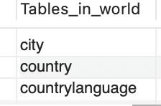

1. **What does the city table store?**

1. **What does the country table store?**

1. **What does the country language table store?**

1. **How can you view all tables in the world database? (Repetitive question, to 2)**

1. **How do you select the World Database?**

1. **How do you describe the structure of the city table?**

1. **How do you list all cities in the city table?**

1. **How do you find the numbers of rows in the country table?**

1. **How do you find the population of a specific city?**

1. **How do you insert a new city, in the city table?**



1. **How do you delete a city from the city table?**

So, in this question, I first tried to delete by name of the city, but it was giving errors,





Then, I tried with the actual city ID, it worked perfectly



1. **How do you update the population of a city?**

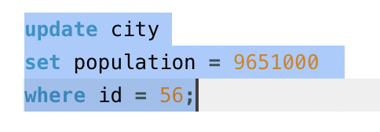

1. **How do you find all countries in a specific continent?**

**16.How do you find the capital city of a country?**

**17.How do you find all languages spoken in a specific country?**

**18.How do you find the official language of a country?**

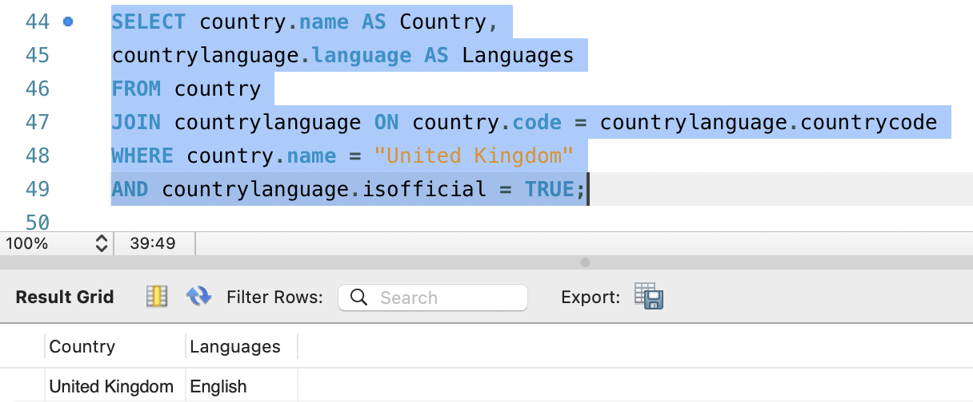

**19.How do you find the countries with the population greater than 100 million?**

**20.How do you find countries in the ‘Asia’ continent?**

**Intermediate Questions**

**21.How do you find the average population of a country?**

**22.How do you find the total population of a specific country**

**23.How do you find the number of cities of a specific country?**